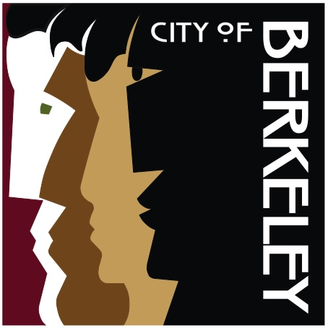
COMMUTER SUBSIDY BENEFIT REQUEST FORM

By submitting this form, you confirm you are a City of Berkeley Employee eligible to receive the $20 (or $80 for CSU only) monthly Subsidy for Mass Transit or Bicycle Travel. Payment of this subsidy ends with termination of your employment.
FIRST NAME
LAST NAME
EMPLOYEE ID
DATE OF REQUEST
UNION

Return this form or ask questions at commutebenefits@cityofberkeley.info.

